1. 2 Models For SAP:

CAPM - Cloud Application Programming Model

RAPM - RESTful Application Programming Model

2. An important thing to know is that SAP Fiori elements generate the application at runtime by combining three fundamental building blocks:

a, OData services

b, OData annotations

c, SAP Fiori element page types.

3.

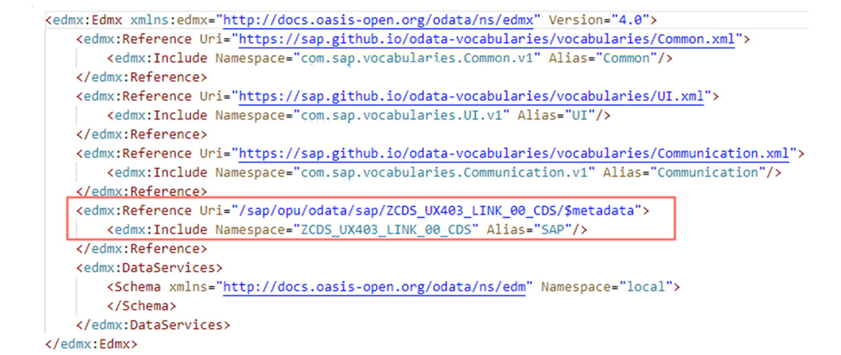

* UI, Common and Communication are vocabulary.
* **Vocabulary** defines how you can add annotations to an OData service. All annotation files must start from references and give an alias to some vocabularies.
* Annotations must be grouped by **targets**.

* **Term and Qualifier:** All annotations must have a term. A term determines the meaning of an annotation. For example, term UI.FieldGroup defines a group of fields. If you have two annotations with the same term for the same target, a qualifier must be added to make your annotation unique.

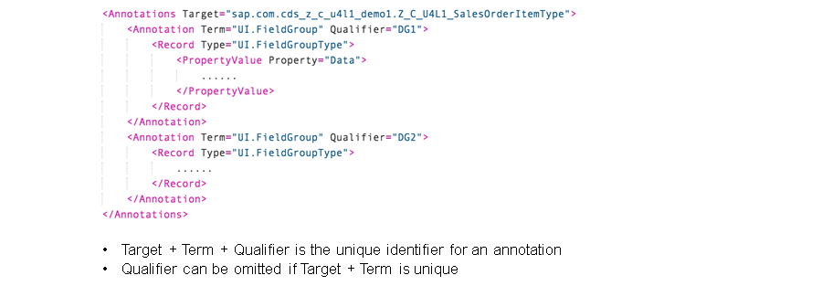

4. **Templates of SAP Fiori Elements**

The current templates for SAP Fiori elements are as follows:

* List Report
* Object Page
* Analytic List Page
* Overview Page
* Worklist Page

5. CDS - Core Data Services

6. [Explaining Basic Annotations for List Report](https://learning.sap.com/learning-journeys/develop-sapui5-applications/explaining-basic-annotations-for-list-report_c8d6bf77-22a0-40ce-87db-ef877ca26326) – Important to create a **list**.



